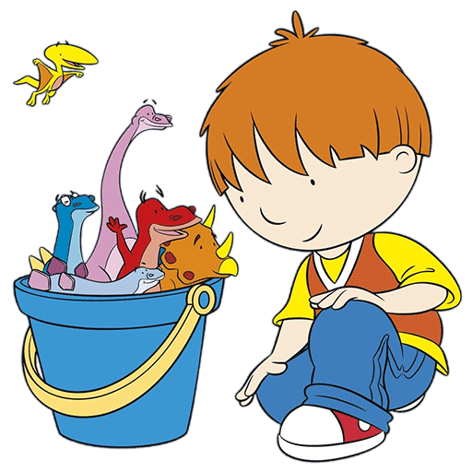

**Diary Dates**

**Thursday 1st March**  
World Book Day  
St. David’s Day

**Monday 6th March**Cross Country Team Competition

**Friday 16th March**Individual School Photographs

**Monday 19th March**Class Photographs

**Friday 23rd March**Year 3 Hoopstarz Festival at The Swan Centre

**Thursday 29th March**Nursery, Reception and Year One End of Term Assembly 9:00am  
Year Two, Three and Four End of Term Assembly 2:45pm  
School breaks up at 3:20pm

**Monday 16th April**School re=opens at 8:55am

*Please ensure that Rex is returned to school with all of his belongings ASAP the following week so that he can go on his next adventure!*

Upon arrival to school you will notice a sign in sheet for your child. This is to encourage name recognition, pencil control and independent writing. Please allow your child to mark make on this sheet independently as it will show their development over their time in Nursery.

Please remember that lunch costs £1.95 per day and you can choose your child’s lunch from home using www.livekitchen.co.uk . Alternatively, you can select your child’s lunch when dropping off in the morning.

A kind reminder that Book Bags must be brought  
to school daily in order for your  
child to choose a new reading book.

I am RAWRR-ly looking forward   
to another exciting half term!

Miss Walsh

Our topic this half term is Dinosaurs!

We will be reading stories from the Harry and His Bucketful of Dinosaurs story collection, as well as various non-fiction information books.

Our classroom has transformed into a Dinosaur Park. We will be needing children to help look after the dinosaurs and work in the Dinosaur Park Gift Shop, selling tickets and dinosaur masks.

Can you help us to spot and identify dinosaurs from the safety of our Dinosaur Den? We will also need to search for buried fossils in the Outdoor Learning Area?

We will be using our imagination in the Creation Station to create dinosaurs while we also sort real dinosaurs into groups using mathematical language.

We will also be listening to music written about dinosaurs and fossils and use our bodies and percussion instruments to make music and take turns too.

Look out for Rex, the class dinosaur. He will be coming home with a child each weekend to create a class diary.

Nursery Newsletter – Spring Term Two

