Spittal School Class 5 and 6 - Autumn Term Newsletter 2018
Dear Parents,
In this newsletter we have outlined the topics the children will be studying this term. Should you require any further information or guidance don’t hesitate to ask. Please feel free to explore these topics with your child and send in any work which you do at home, as it is wonderful to share this with the rest of the children.
Yours faithfully,
Mr Hair and Mr Straughan
Literacy
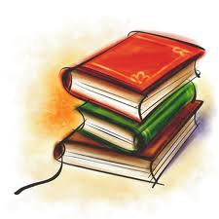
We shall start the term off by writing about ourselves. We will then write an adventure story based around Berwick. We will enter the best stories into the Rotary annual short story writing competition. Following on from this we will look at newspaper articles and try and write an article set in Anglo-Saxon times about the Vikings raiding Lindisfarne. We will also write a Viking information text. Throughout the term the children will also be working on improving their spelling, punctuation, grammar and handwriting.
Maths
In maths we will be reinforcing our basic numeracy skills including place value, addition, subtraction, multiplication and division. The curriculum encourages the use of column methods for addition and subtraction so we shall have lots of fun experimenting with these techniques, as well as using number lines and squares. We will also be working hard to learn our times tables. By the end of Year 4 it is now expected that children will know all their tables up to 12 x 12!

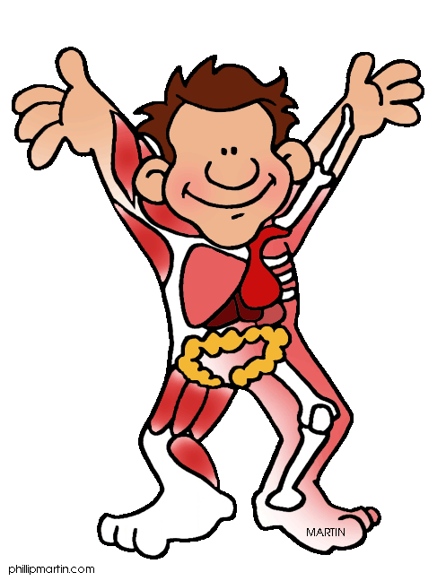
Science – Animals, including humans
We will be looking particularly at eating a healthy diet and human and animal skeletons.
History – The Vikings
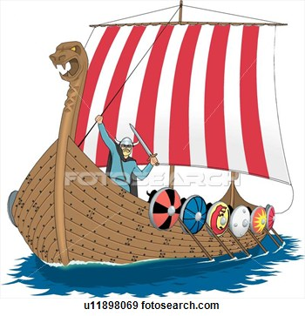
We will be studying the Vikings from their first invasion at Lindisfarne to their eventual settlement in much of the country. We will find out who the Vikings were, where they came from and when they lived. We shall study Viking long ships, settlements and houses, and examine their relationship with the Anglo-Saxon king, Alfred the Great. We will consider how the Vikings were different to us. We shall also look at other aspects of Viking culture such as religion and writing.
Information and Communication Technology
This term we are going to look at E-safety.
Music
Year 4 will be working on improving their singing with our fantastic singing teacher Frances Orde.
Physical, Health and Social Education
This term we will be looking at ‘New Beginnings’, for example how we approach starting school or moving home.
September 2018 Nick Hair and Liam Straughan

