cccccccccccccccccccccccccccccccc
Literacy

Fiction – reading and writing stories with familiar settings
Non-fiction – writing labels, lists and captions
Poetry – reading and writing poems about animals.
We follow the Letters and Sounds scheme for phonics and have a daily phonics lesson to support our reading and spelling.
Topic

Myself and Other Animals

During this topic we will be finding out about our bodies, naming body parts and exploring our senses.
We will also be finding out about different animals. We will name and describe a range of animals and look for similarities and differences between them.
All of our artwork will be based around this topic. We will be drawing, painting and printing.

PE

Mr Crozer is coming into school every Wednesday to teach PE. The children will be working on a range of ball skills.

Please ensure earrings are removed before school.

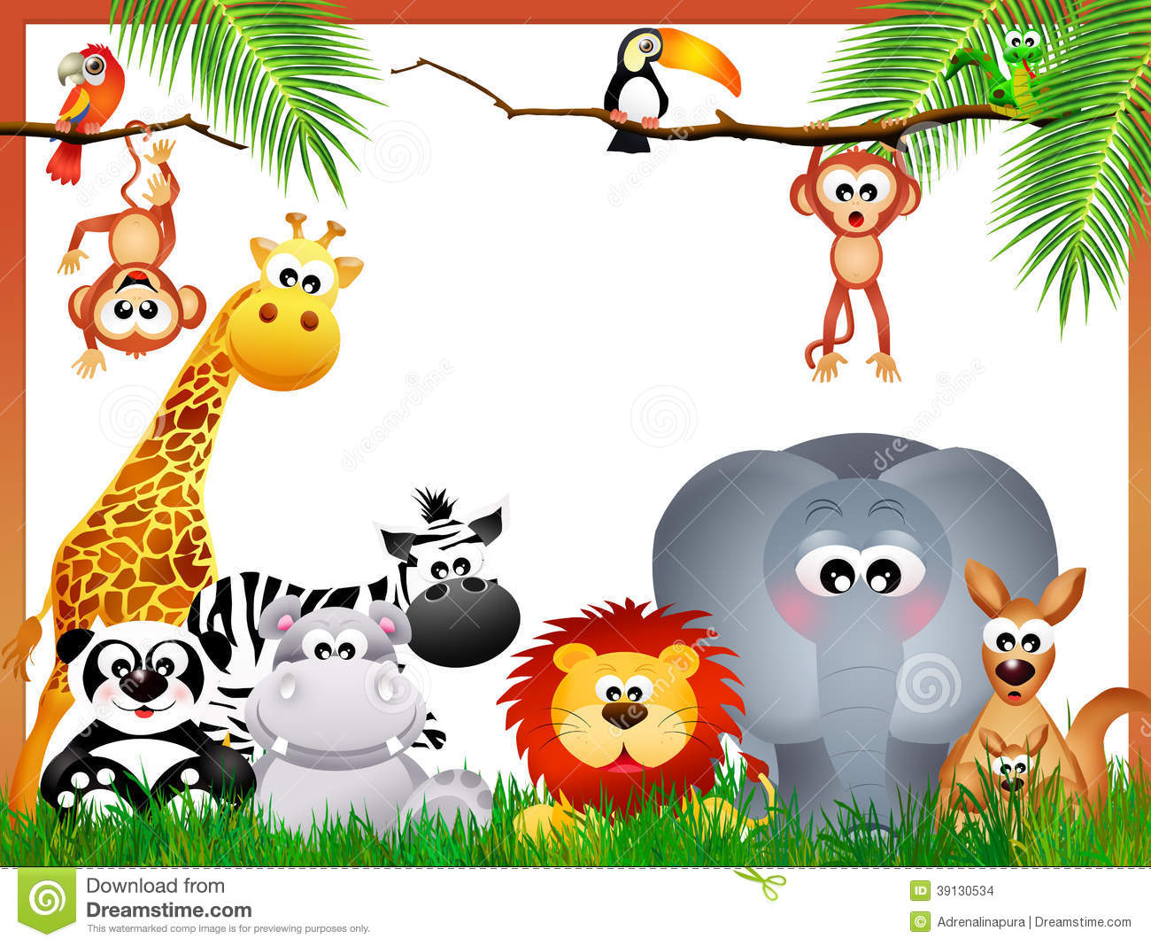

Year 1 Newsletter
Autumn
Half Term 1

Numeracy

This half term we will be counting to 100 in groups of 1, 2, and 10. We will be using apparatus such as counters to help us add and subtract numbers to 10 or 20. We will also be measuring by comparing the weights or lengths of different objects. We will also be identifying and describing 2D and 3D shapes.
We will be following BIG Maths planning and be having a daily CLIC (counting, Learn Its, It’s nothing New and Calculations) session. This is to improve the speed in which number facts can be recalled and used.

SEAL (Social and Emotional Aspects of Learning)

New Beginnings – talking about our feelings and describing how we feel in different situations. Also, exploring the theme of belonging to certain groups, and what this means.

Music

We use the Charanga online programme for our music lessons.
We will be singing a variety of songs and playing accompaniments on percussion instruments.
We will also be learning songs about Autumn and Harvest.

RE
We will be learning about the Creation story and Harvest.

