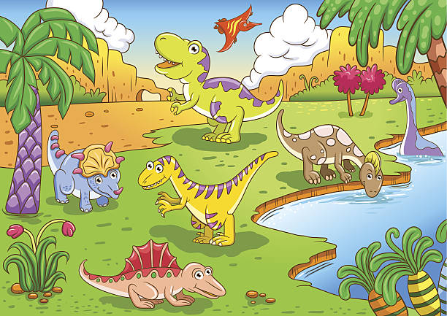

**PE**

For PE we will be using a range of equipment to play team games. We have PE every Wednesday morning. Please ensure earrings are removed before school.

We will be swimming every Tuesday afternoon. Please remove earrings before school. A small reminder that swimming money should be brought to school on a Monday in a named envelope.

# Mathematics

This half term we will be counting in steps of 2,3,5 and 10 from 0 and any given number, forwards and backwards. We will be identifying and representing numbers using objects and pictorial representations including a number line. We will use addition and subtraction facts to 20 fluently, solve problems with addition and subtraction, applying knowledge of mental and written methods.

**Literacy**

Information Texts - Reading to gain information, using dictionaries and encyclopaedias. Making notes from non-fiction texts.

Stories by the same Author - ‘Harry & The Dinosaurs’ Looking at the author’s life, creating fact files and giving an opinion of his work.

Poetry- Looking at features of poetry with a focus on rhyme. Producing shape and acrostic poems.

**Spelling**

We will follow the Read Write Inc spelling scheme. This half term our focus will be adding the suffixes –y, -ly.

# Music

We follow the ‘Charanga’ scheme of work. During our lessons we will be singing a variety of songs and playing accompaniments on percussion instruments.

**Topic**

Myself and other Animals

“Would a dinosaur make a good pet?”

During this topic we will be finding out about our bodies, naming body parts and exploring our senses.

We will also be exploring dinosaurs using ICT and non fiction books. We will be looking for similarities and differences between wild and domestic animals and using maps to plot where dinosaurs lived (Oceans and Continents).

All of our artwork will be based around this topic. We will be drawing, painting and printing.

**R.E.**

We will be learning about the Creation story and Harvest.

**Year 2 Newsletter**

**Autumn**

**Half Term 1**

# SEAL (Social and Emotional Aspects of Learning)

New beginnings - talking about our feelings and describing how we feel in different situations. Also, exploring the theme of belonging to certain groups, and what this means.