P.E and Sports Funding
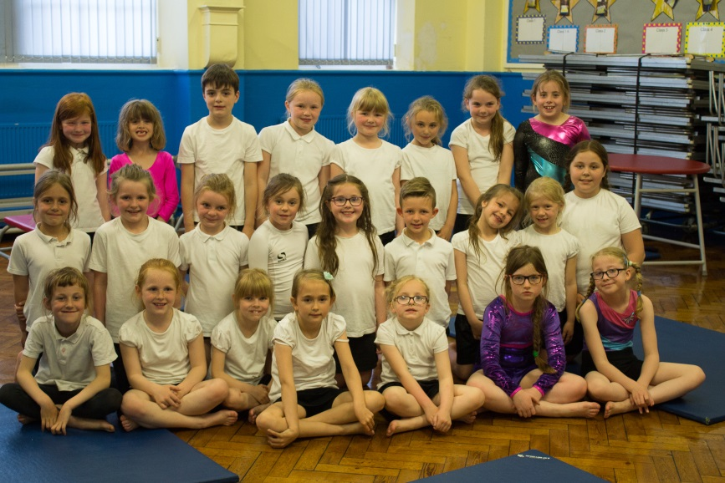
The sport premium is an amount of money the government have allocated to schools to improve their provision of PE and sport. In the year 2016-2017 Spittal First School was allocated £8532.
We allocated this money in the following ways;
£6500-Participating in the North Northumberland P.E and School Sport Programme
£900-Additional coaching, teaching assistant support and supply cover
£1165- Coach travel to events, competitions and festivals, resources and equipment

Through participation in the North Northumberland P.E and School Sport Programme the service provided included the following;
- Six two hour five week blocks of curriculum specialist PE teaching, including after school or lunchtime clubs.
- CPD- teachers have benefitted from a range of high quality CPD.
- Sports Festivals including multi-skills, Hoopstarz and skipping. These are over and above the normal school games competitions and have encouraged wider pupil participation.
- Summer sports programme- A 10 week programme of sports which gives children the opportunity to participate in a wide range of sports alongside or against pupils from their own and other partnership schools.
- Development of school-club links.
The impact has been;

- Children across school participated in specialist coaching sessions in rugby, football, dance, cricket, athletics and tennis including lunch and after school clubs.
- Teachers received training in Fundamental movement skills, active numeracy and dance.
- School teams participated in a greater number of competitions this year including tri-golf, football, gymnastics, cross country and rugby.
- Children from a range of age groups attended festivals for multi-skills, hula hooping and skipping all of which had a positive impact on activity levels at playtimes.
- The development of a sports crew allowed children to take responsibility for supervising playground sports activities developing confidence, social skills and self-esteem.
- Summer sports programme events were well attended with children participating in quick sticks, rugby and football events.

